Marvellous Infosystems: Angular Assignment 3

1. Solution:

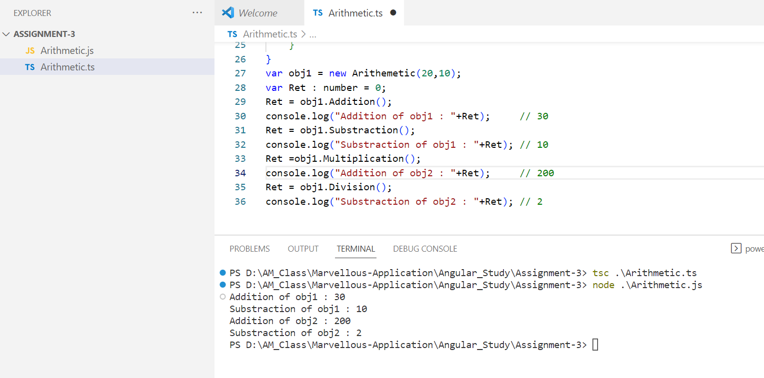

1. Solution:

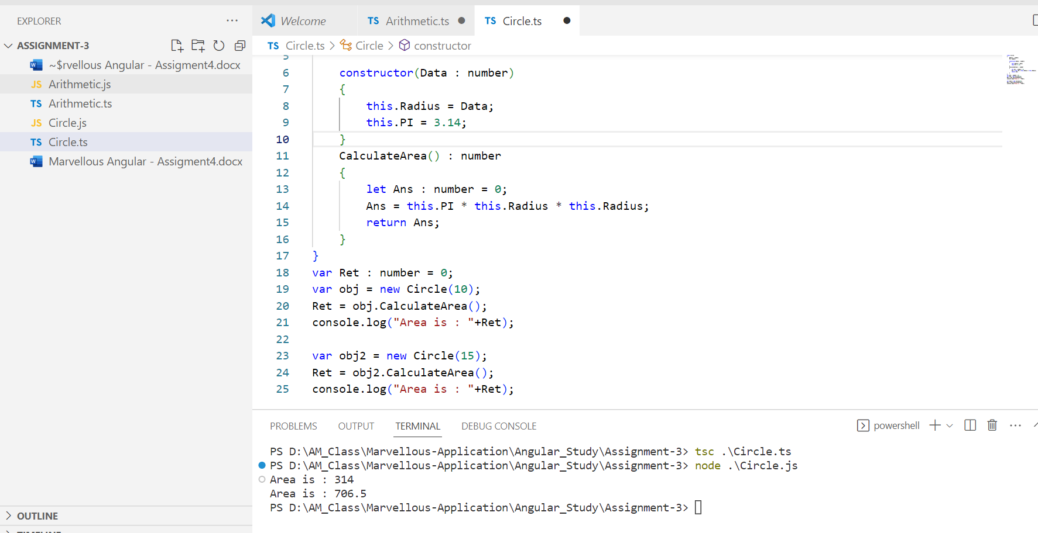

1. Solution:

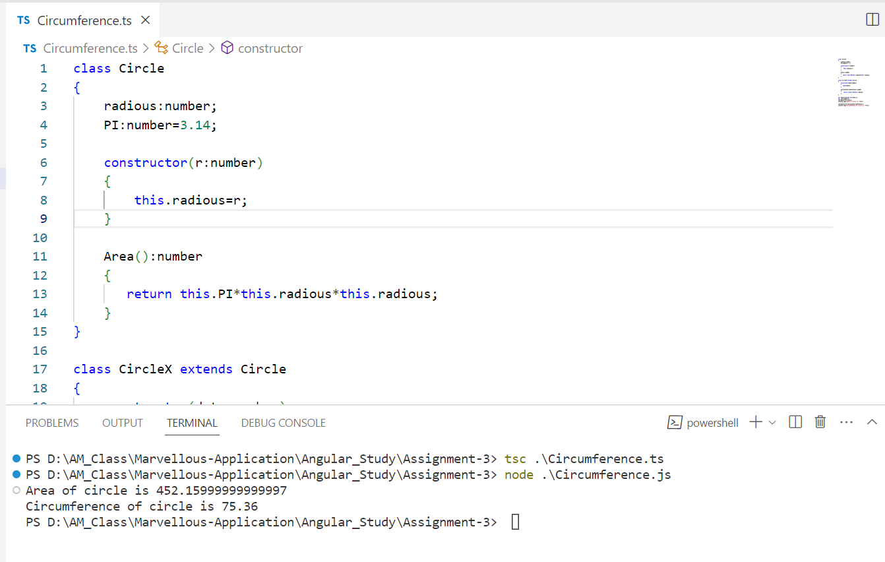

1. Solution: